


FORM-22G

I N T E R N S H I P J O U R N A L
(Progress and Accomplishment Report)

WEEK NO:___Three (3)_____ COVERED DATE/S: ____March 5-March 9, 2024___

TRAINING ACTIVITIES/DESIGN TASK  (Brief project information and designed details of the project. May attach media files and hyperlinks) | RENDERED HOURS
- Contributed on a client project dedicated for Danny (1st Pastoral Program by doing a small bifold booklet.  - Continuation on IG Carousel Widespread Post  - Providing Variety on Harmony Rose Washington Program by trying out pink theme. | 24.19 hrs.
- Continuation on IG Carousel Widespread Post  - Continuation on IG Carousel Widespread Post | 16.39 hrs.
TOTAL | 40.58 HRS
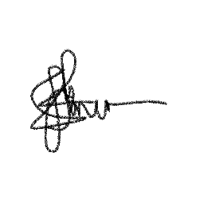
INTERN’S NAME: TRAINING SUPERVISIOR:

_____Ian Carlo A. Jimena______ ______Ms. Karen Faustino_____
Provide additional row/page if necessary
Signature over Printed Name
Signature over Printed Name

